

**UNIVERSITY OF PETROLEUM AND ENERGY STUDIES**

**School of Computer** **Science**

**2020-21**

**GRAPHICS AND ANIMATION TOOLS LAB**

**Faculty: Dr. DURGANSH SHARMA**

**Assistant Professor**

**Department of Cybernetics.**

**School of Computer Science, UPES**

**Submitted By:**

**Name- Vartika Deep**

**Roll no-R100217088**

**Batch-B3**

**Semester- VII**

**Course-B.Tech CSE(OS&OS)**

**Sap Id- 500062441**

**EXPERIMENT-8**

**Design of 3D Car using Blender**.

**STEPS:**

1.Select the cube and scale it along z-axis.

2.Make two loop cuts on the cube. Select upper face ,extrude it and scale it to make the roof of the car. Then, Select the front edge of car roof and move it backward to provide the front view of the car.

3.Add a cylinder, rotate it 90 degrees to make the wheel of the car.

4.Go to edit->preferences->add bool tool. Select wheel and car. Go to Object->Bool Tool->Brush Boolean->Differences. It will make a cut on the car according to the shape of the wheel.

5.Selcet the cube. Add mirror modifier and select the car. Again, Select the wheel. Add mirror modifier. This will add another wheel on the opposite side of the car.

6.Duplicate the wheels and move them to the back of the car.

7.Add a cube to make the lights of the car by scaling and moving it.

8.Duplicate the lights and move them backwards to make the side mirrors of the car.

9.Add another cube to make the number plate of the car.

10.Colour the car.

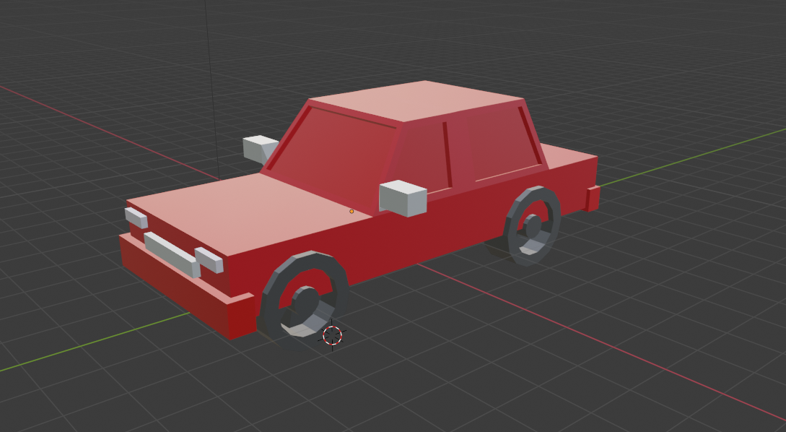

Link:

https://drive.google.com/file/d/1h5tavPnMQt1mvfaaMGM3mpOncNFyOCKJ/view?usp=sharing